

FOR SALE

­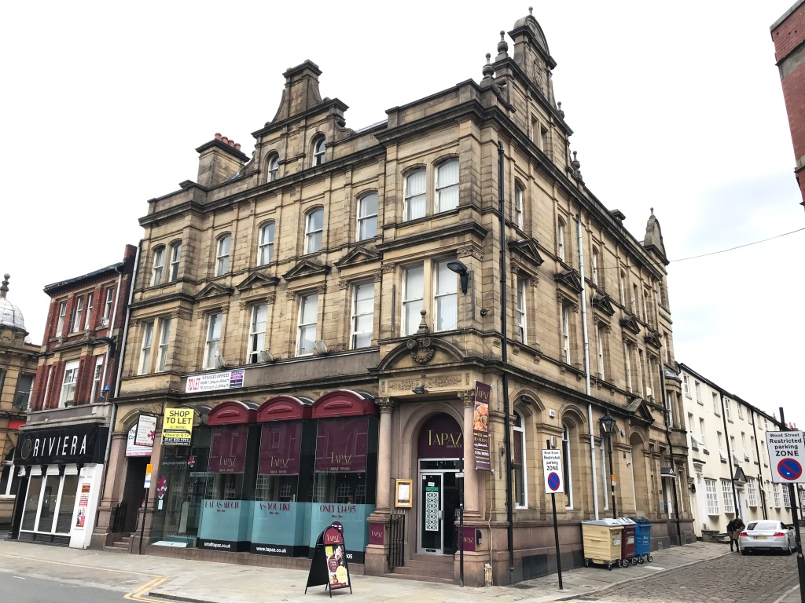

27-33 Bradshawgate, 1 Wood Street, Bolton, **BL1 1EP**

Multi-Let Retail/Restaurant/Office

Investment   
7,518 Sq Ft (698.42 Sq M)

• Prominent Period Four Storey Building

• Town Centre Location

• Opposite Crompton Place Shopping Centre

•

­­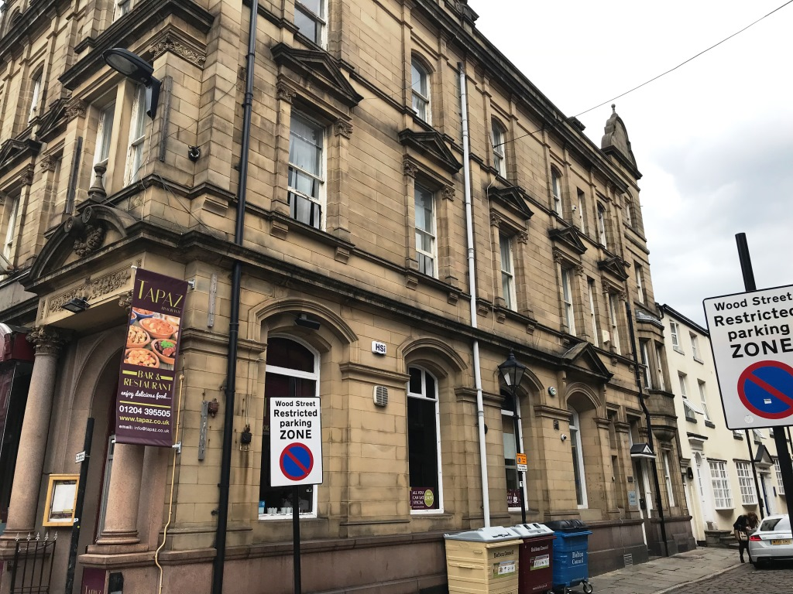

­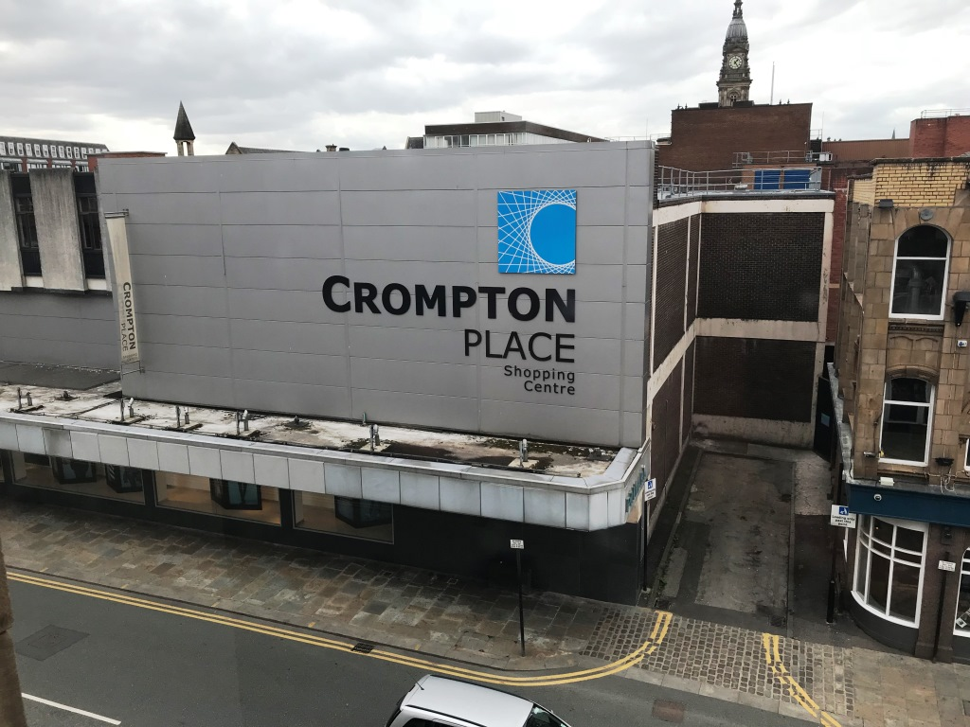



27-33 Bradshawgate, 1 Wood Street, Bolton, **BL1 1EP**

**Location**

The property is situated fronting Bradshawgate at the corner of Wood Street in the centre of Bolton, being positioned directly opposite the Crompton Place Shopping Centre and Primark. The Crompton Place Shopping Centre is earmarked for a £250 million renovation as part of Bolton's £1 billion master plan. Bolton is a traditional market town, approximately 10 miles north west of Manchester with a population of 139,403 with the wider metropolitan borough having a population of 262,400.

**Description**

Substantial period Victorian four storey building, briefly comprising two ground floor retail/restaurant units with multi-let office accommodation/business centre to the first, second and third floors separately accessed from Wood Street. The upper floors are considered suitable for residential conversion subject to the necessary consents being obtained.

**Accommodation**

We have not measured the accommodation, however we have been provided with the following net internal floor areas:

Ground Floor

Tapaz Restaurant 1,313 sq ft

Vacant 1,034 sq ft

First Floor Suite 101 175 sq ft

Suite 102 150 sq ft

Suite 103 365 sq ft

Suite 104 154 sq ft

Suite 105 555 sq ft

Total 1,399 sq ft

Second Floor

Suite 201 194 sq ft

Suite 202 214 sq ft

Suite 203 80 sq ft

Suite 204 130 sq ft

Suite 205 125 sq ft

Suite 206 244 sq ft

Suite 207 106 sq ft

Total 1,093 sq ft

Third Floor

Suite 301 217 sq ft

Suite 302 226 sq ft

Suite 303 103 sq ft

Suite 304 245 sq ft

Suite 305 120 sq ft

Suite 306 181 sq ft

Total 1,092 sq ft

Basement

Storage 1,587 sq ft

Total 7,518 sq ft (698 sq m)

**Purchase Price**

£595,000

**VAT**

All figures quoted are exclusive of but may be subject to VAT at the prevailing rate.

**Tenure**

Assumed to be Freehold.

**Service Charge**  
33 Bradshawgate D (82)

27 Bradshawgate E (104)

A copy of the EPCs are available on request.

**Viewing & Further Information**

If you would like to view this property or would like further information please contact the Sole Agents:

**Stuart Cooper**  
T: 0161 817 3399 (Option 1)

E: [stuartcooper@roger-hannah.co.uk](mailto:jkl@roger-hannah.co.uk)

**Date of Preparation**

18 June 2019

­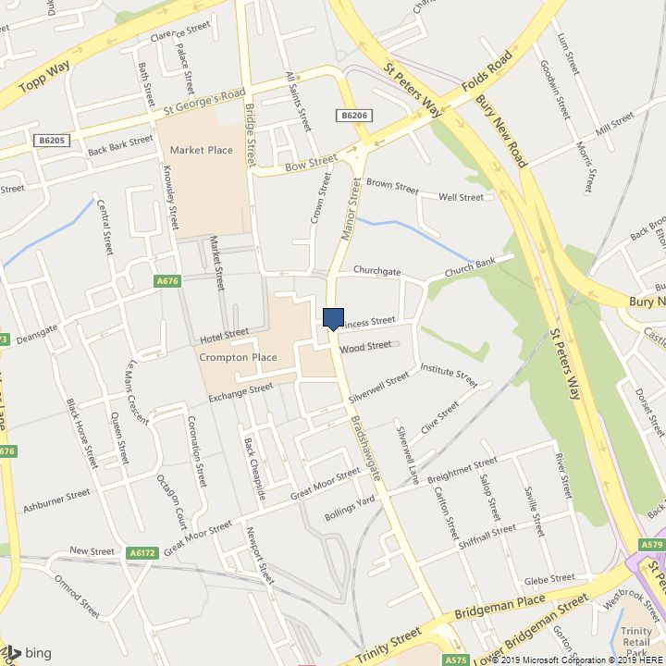

­­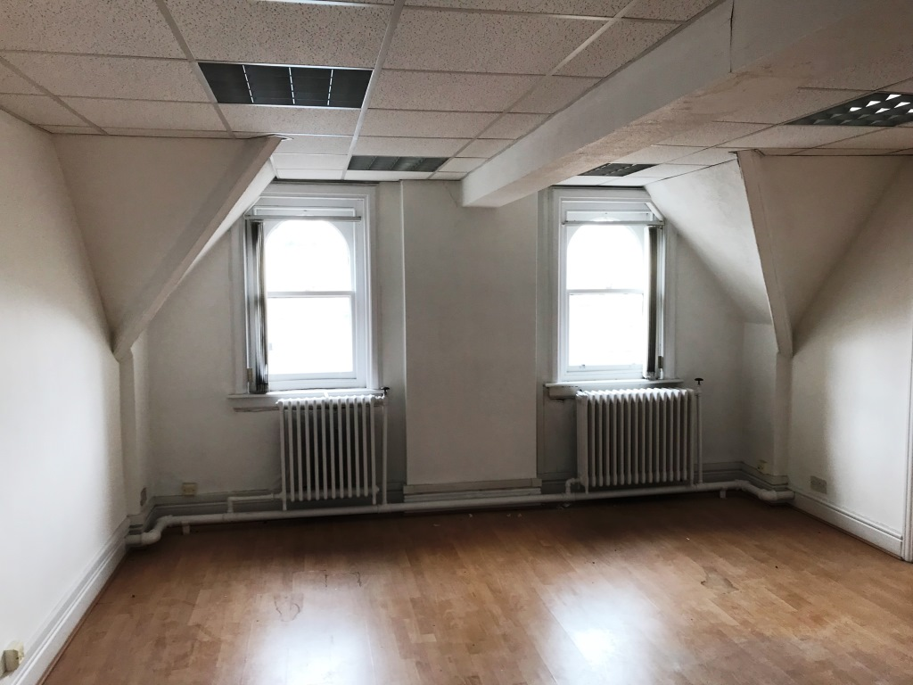

27-33 Bradshawgate, 1 Wood Street, Bolton, **BL1 1EP**



27-33 Bradshawgate, 1 Wood Street, Bolton, **BL1 1EP**

­­

